

**REASONS TO LOVE 369links**



**REASONS TO LOVE  
369links**



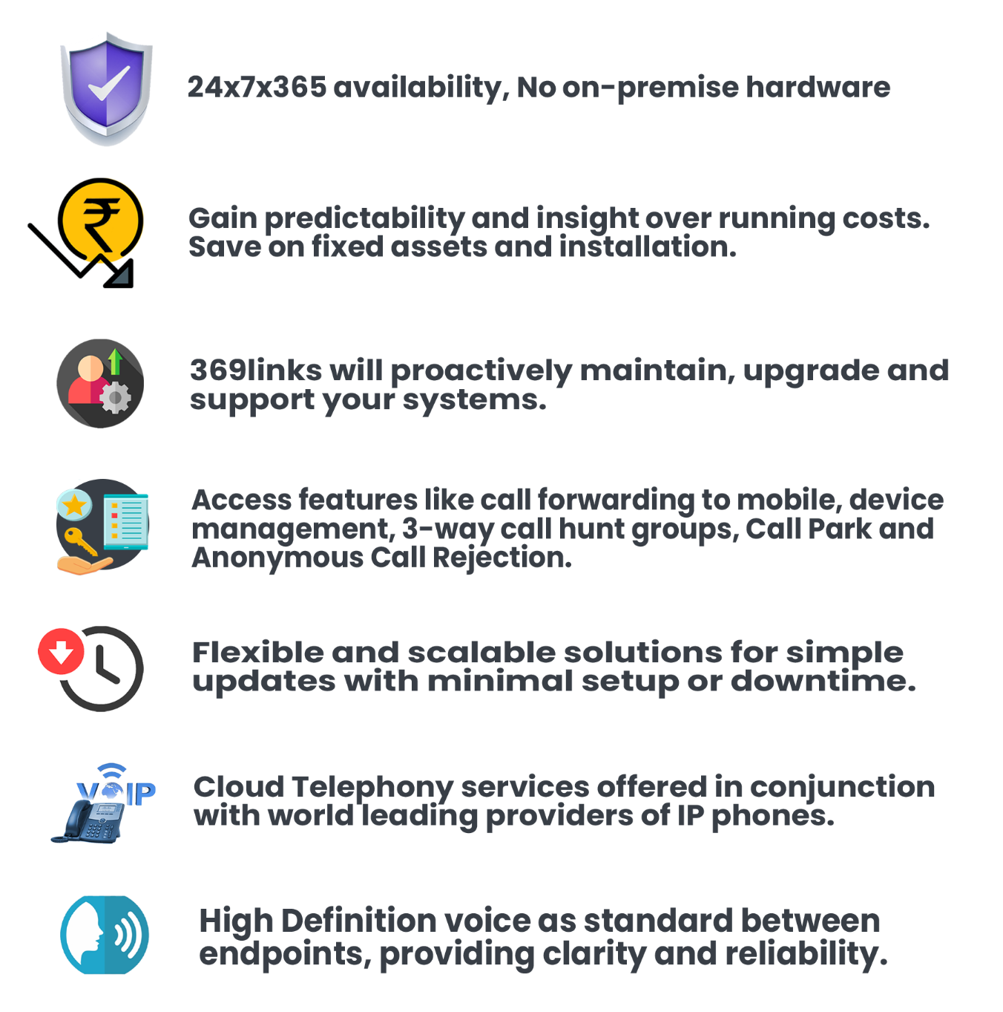

Welcome to 369links from Eastside! This user guide will help you get started on setting up your business phone system! If at anytime you need further assistance, don’t hesitate to reach out to ecs369links Customer Success team at: [Support@eastsideworld.com](mailto:Support@eastsideworld.com)



# Contents

* **Accessing 369 links… 1**
* Signing up 369links for the first time.
* Adding Apps to Your Dashboard.
* Your Personalised Dashboard
* Call routing overview
* Smart PBX: Setup Your Office.
* **Setting up your first office… 2**
* Create Users / Add extension
* Assign Numbers
* Provision Devices
* Manage User Features
* Create and Manage User Groups
* Manage Your Office Strategy
* Set up your virtual receptionist
* Easy Call Logs
* Personal Conference Rooms
* **Using the Desktop app… 3**
* Download and install 369links “Desktop app”
* Login with the user credentials
* Using the 369links Desktop app
* **Using the Mobile Phone app… 4**
* Download and install Mobile Phone App
* Configuring the Mobile Phone App
* Using the Mobile Phone App

## Accessing 369links



**Step 1: Signing up 369links for the first time**

Now that your 369links account has been activated, you can start building your business.

**To get started,** 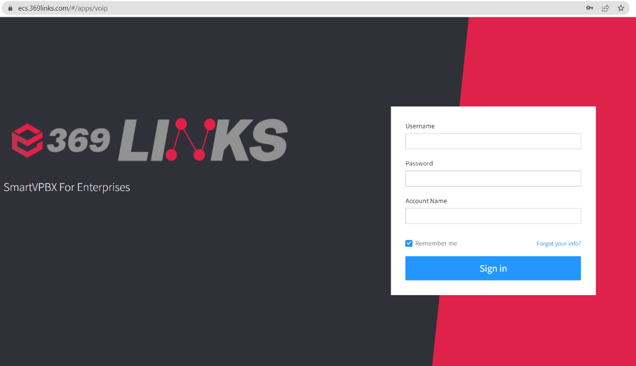

* Please go to <https://ecs.369links.com/>
* Enter Username
* Enter Password
* Enter Account Name
* Check ‘remember me’ (If you don't want to enter your credentials manually every time you enter)
* Click Sign In

### **Step 2: Adding Apps to Your Dashboard**

### After logging in, your 369links dashboard will be displayed along with the available Apps. The first time you access 369links,

### You’ll need to activate the Apps you want to use.

### Click on the App you are interested in using and turn it on.

### All of the Apps that have been turned on can be accessed when you click on the “Apps” icon on the top right corner of the UI.

### 

### **Step 3: Your Personalised Dashboard**

The first App you should access is Smart PBX. This is where you manage your business phone numbers and how they handle incoming and outgoing calls.

### **Overview**



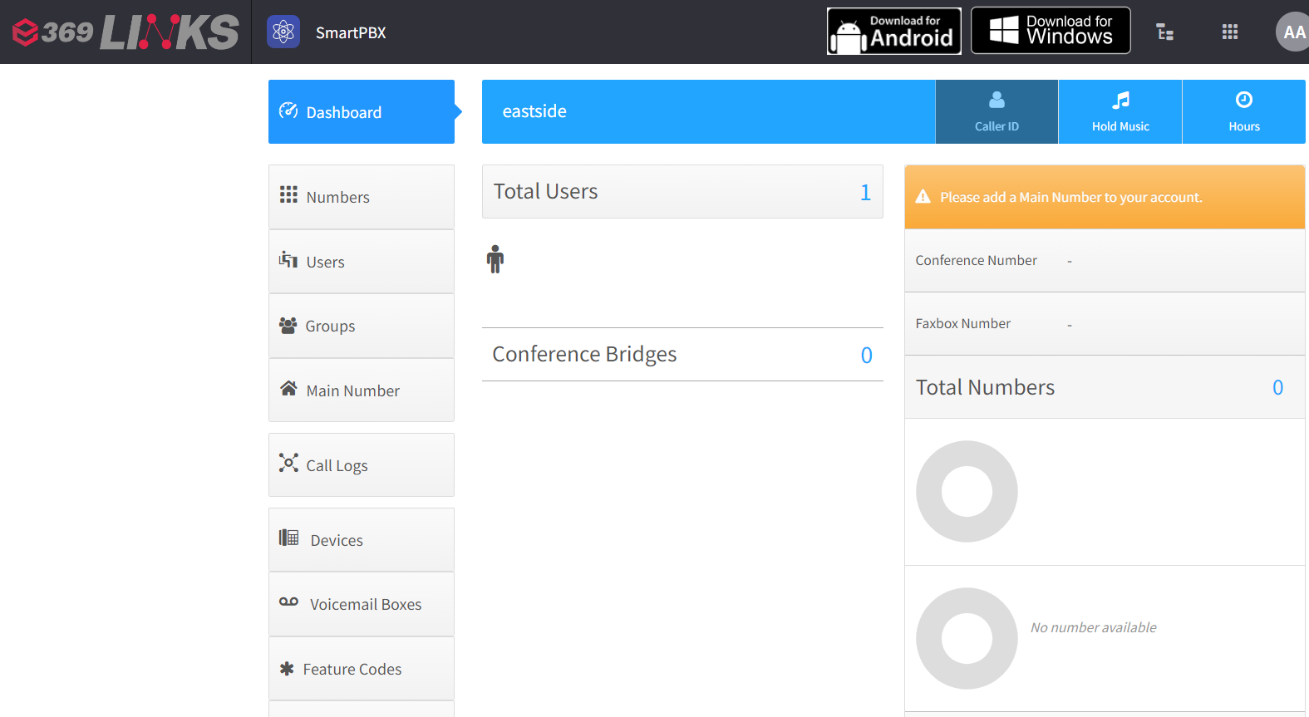

**Step 4: Call Routing Overview:**

The 369links business phone system can route incoming calls in a number of ways. The components that make up the system are illustrated in the example below:

1. **369links Numbers:** When people want to call you, they will dial your 369links number. You can set up your 369links number to forward calls in a few different ways. It can send the call to voicemail, it can go directly to an extension, or it can go to a virtual receptionist.
2. **Virtual Receptionists:** Let’s say you connect your number to a virtual receptionist. The

virtual receptionist will answer right away when people call your number and present them with options like “for sales press 1, for support press 2”. Depending on the option the caller chooses from their keypad, the virtual receptionist will route the call accordingly.

1. **Extensions:** Let’s say for example that the caller pressed 1 to connect to my sales department. I could create an Extension for my sales department that would detail exactly what should happen when the extension is connected to. For example, I may want an office phone to ring, as well as three of my employee’s cell phones. I can set the order that the phones ring or have them ring all at once.

So there you have it, from a caller dialing your number, to someone on your end picking up the phone. There are an endless amount of ways that your business phone system can route calls.

**Step 5: Smart PBX: Setup Your Office**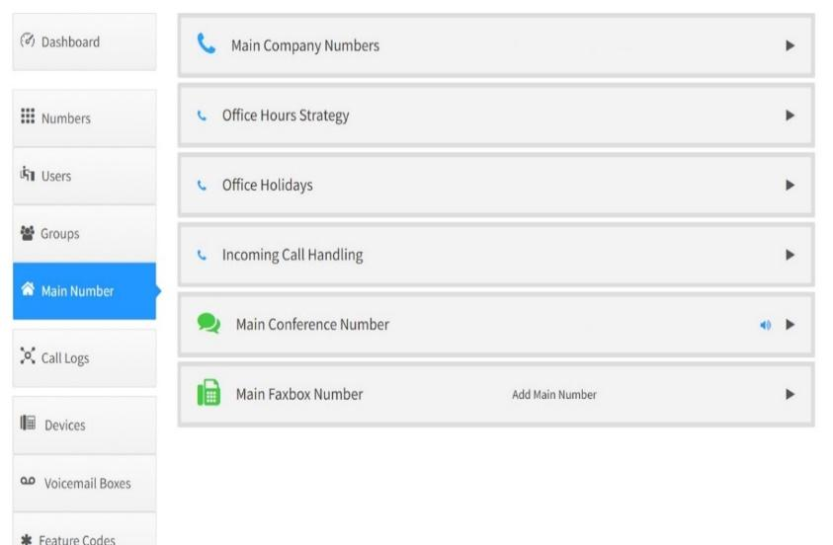

In the Main Number tab, add a main number

### choose an office hour strategy

### choose how incoming calls are handled

### customize your IVR and set up your main conference number.

### You can choose a number that is in the spare numbers, purchase a number or port a number.

### 

**Setting up your first office**



## Step 1: Create User/ Add extension

Create users and manage all of their settings, all within Smart PBX.

**To create a new user,**

* Click on the “users” tab to the left of the dashboard. 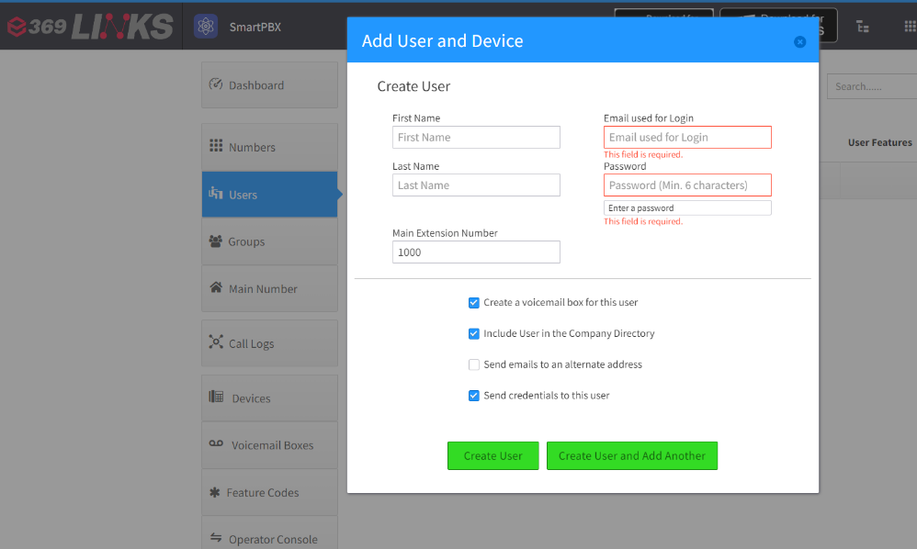
* Then click on the “Add User”
* Provide your user’s first name, last name, email address and create a password. The user can change this later.
* Add Extension number here
* Send information via email to user. Add user to company directory.

### **Step 2: Assign Numbers(optional)**

Provide your new user with their unique direct-dial phone and extension number. You can assign a spare number within the interface after you buy or port a number. When a number is ported or purchased, it will populate the spare numbers tab.

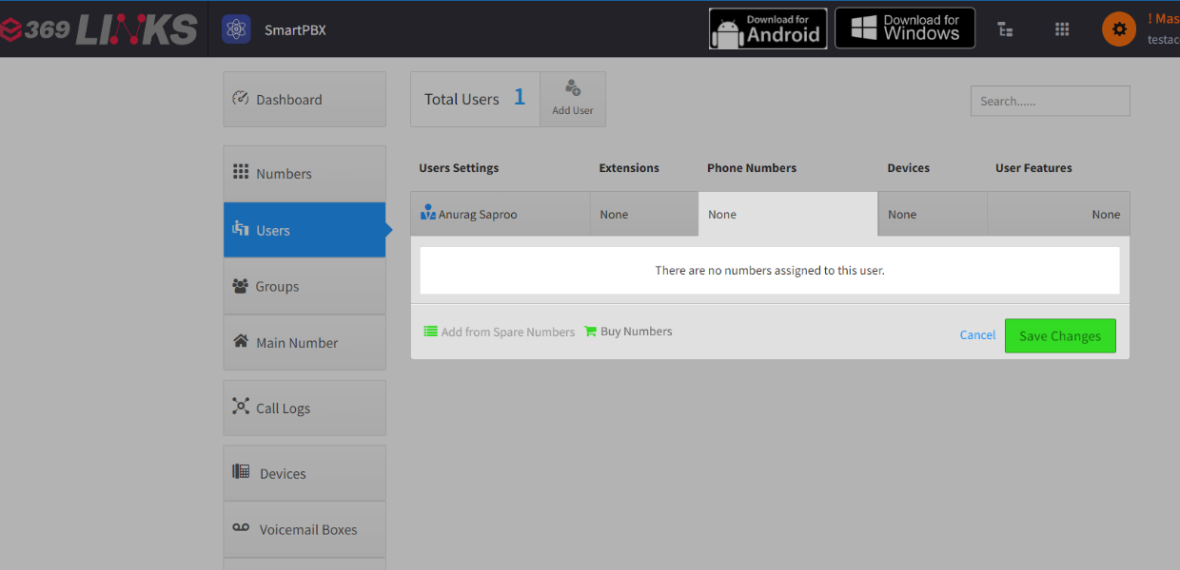

**To assign a number,**

* Click on the “Users” tab of SmartPBX
* Select “Phone Numbers” next to the users name.
* Then click on to the “Add from Spare Numbers” button and add the selected number.

### **Step 3: Provision Devices** Determine which device should ring when your extension is called in the “Devices” section

**To add a device,** 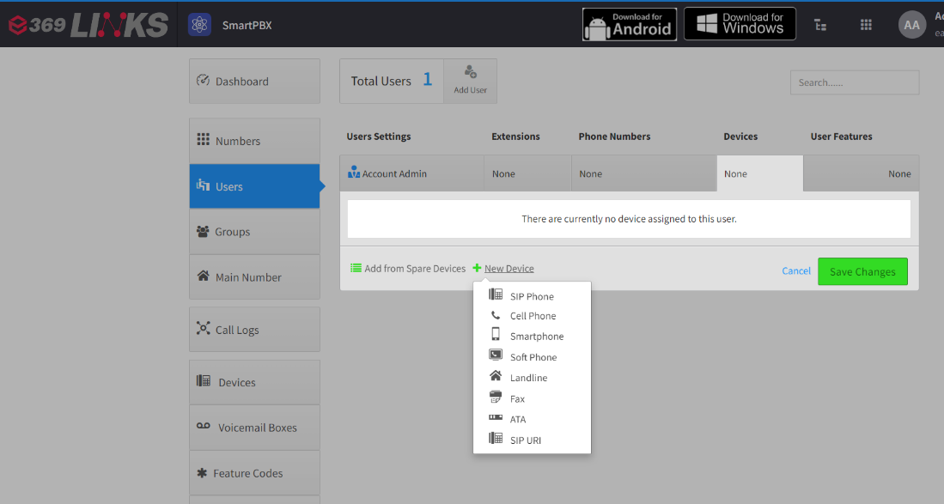

* Select “Devices” next to the users name.
* Click “New Device” and choose the type of device you’re adding.
* Select Soft Phone
* Enter your Device Name, Your Sip Username, Sip Password and Assign To and click create Device

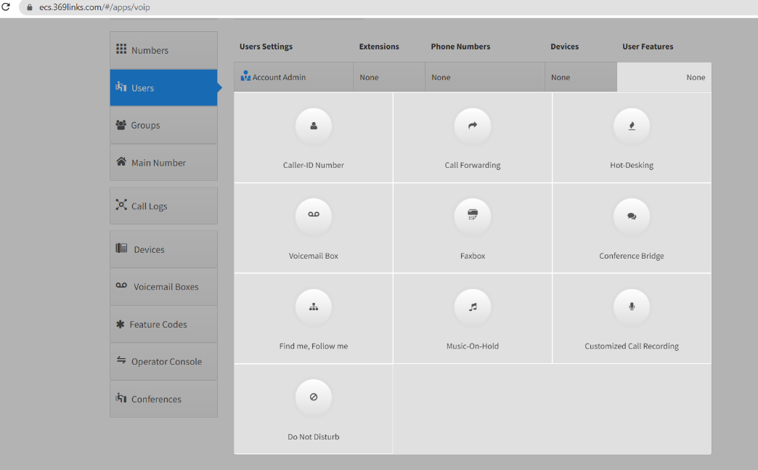

### **Step 4: Manage User Features**

You have the ability to turn on/off and manage

1. Caller ID
2. Call Forwarding
3. Hot Desking
4. Voicemails
5. Faxbox
6. Conference Bridge
7. Find Me- Follow Me
8. Music-On-Hold
9. Inbound Call Recording for all of your users.

**To manage User Features,**

* Click on the “Users” button in SmartPBX. Next
* Click on the specific user’s “User Features” button.
* From there, you can turn on or off User Features.

### **Step 5: Create and Manage User Groups**

Once you have created enough users, you can begin creating user groups. This is extremely useful if you have users that work in the same department, such as a sales or marketing team.

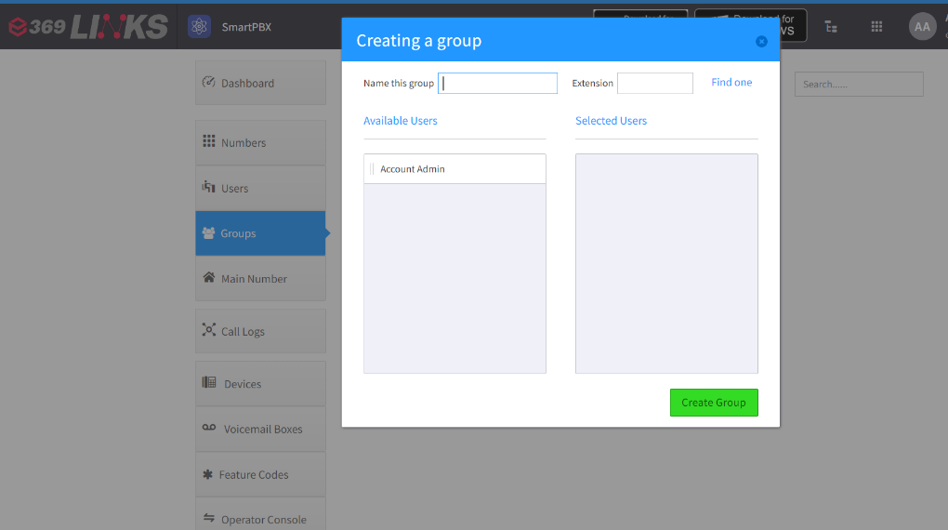

**To add a new group,**

* Click on the “Groups” tab in SmartPBX
* Click “Add Group.” The interface has a handy drag and drop.
* Drag the available users over to selected users,
* Create a name for your new group and add an extension.

### **Step 6: Manage Your Office Strategy**

Within the Main Number tab of SmartPBX, you can set an Office Hours Strategy and add holidays for when your office will be closed.

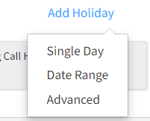

## Step7: Set Up Your Virtual Receptionist Edit how your Virtual Receptionist greets callers in the Greeting section. If you want callers to be able to press numbers to connect to extensions, make sure to tell them what their options are in the greeting: i.e “For sales press 1, for support press 2”, To add welcome message

## Go to – Main Number tab- incoming call handling- virtual receptionist

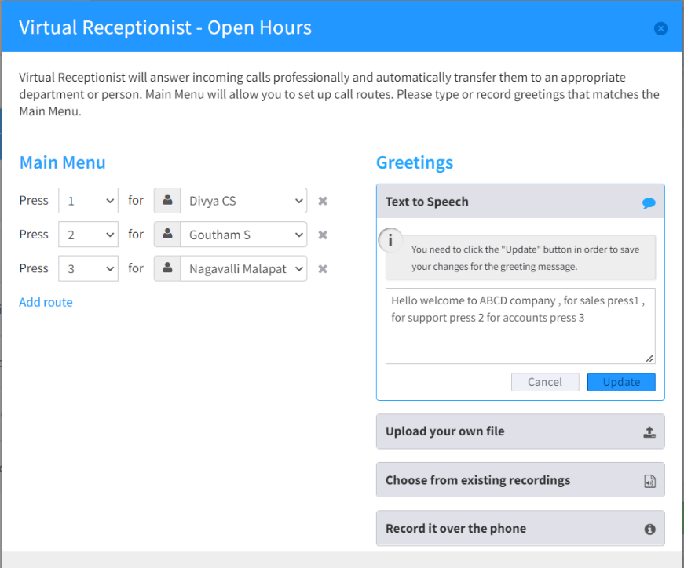

* You can use our text to speech voices by typing in the text box and clicking update.
* You can also upload an audio file or make a voice recording on the spot using the other options here:
* Add routing from here press 1, press 2 to particular department wise or user wise

Note: you can setup virtual receptionist only when main number is added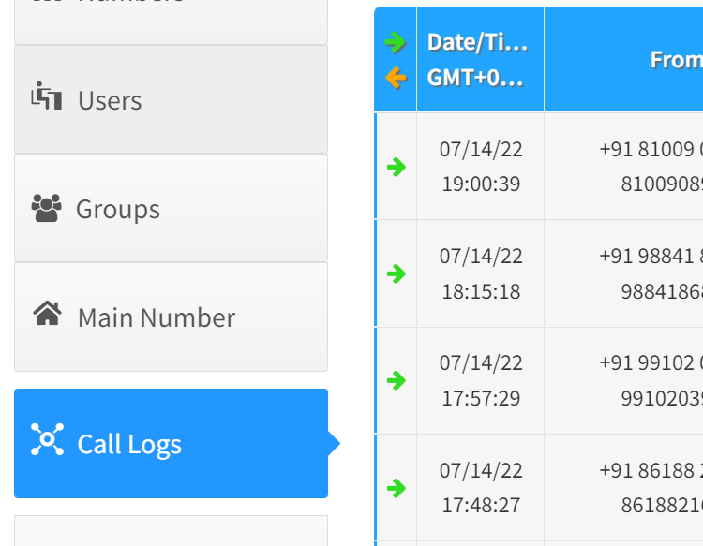

### **Step 8: Easy Call Logs**

You never need to struggle to find a number again. More importantly, you can diagnose call delivery problems with ease. Every call is tracked, and every device that rings or is attempted is shown. Your call problems can also be reported with a single click.

### **Step 9: Personal Conference Rooms**

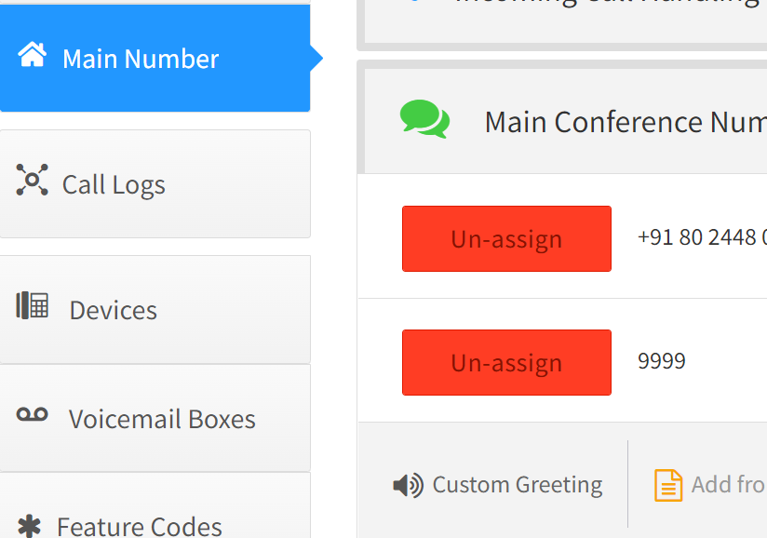

Every user can have their own conference bridge and unique pin. This avoids users scheduling conference “rooms”. Use the conference whenever you like – it’s always available. No scheduling required.

**Using the service**



**Step 1: Download and install 369links “Desktop app”**   
  
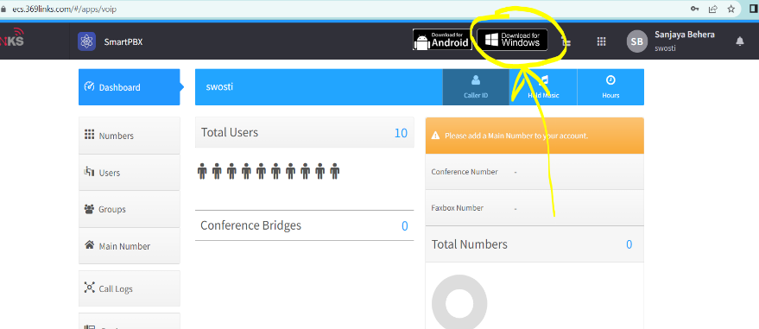

To Download the desktop app, click on this **Download for windows** button from the dashboard upper right side

* 1. Click on **Download** option from here  
       
       
       
     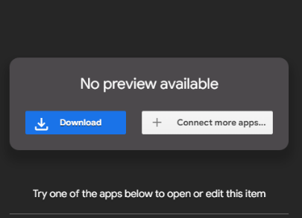
  2. Click on **Download Anyway** to download the Desktop App  
       
       
       
       
     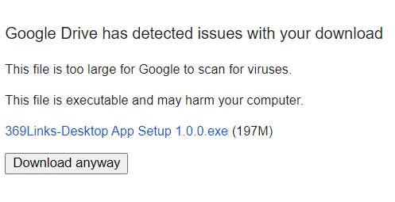

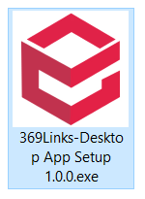

* 1. After downloading double click on the

**369Links-Desktop App Setup 1.0.0.exe** file

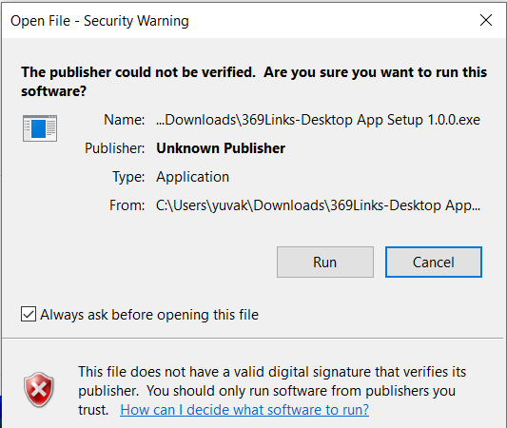

* 1. Click **Run** on this window.
  2. Click on **I Agree** To install the app  
       
       
       
       
       
       
       
       
       
       
       
       
       
     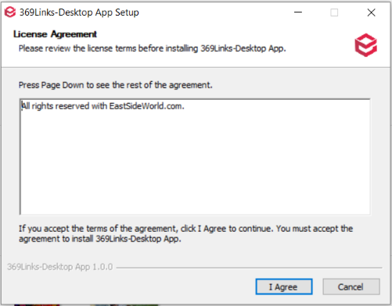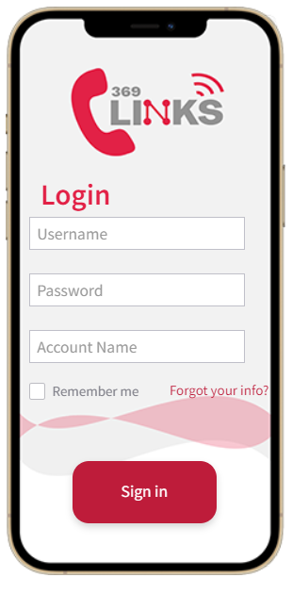

Step 3: **Signing into 369links Desktop app**Use your credentials to login to the Desktop App **Example:**Username:   
Password:   
Account Name:

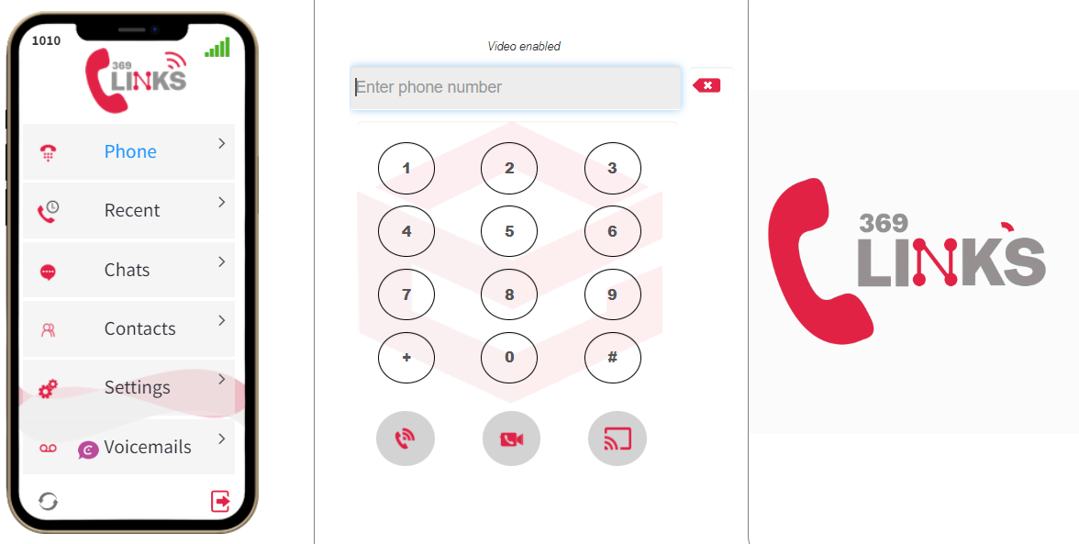

One you login to the app this interface will come

**From here you can make**

* Audio call
* Video call
* Call transfer

## Place Calls in the Desktop app

1. You can place a call by either entering a number in the keypad or choosing a contact in your contact list
2. **Phone tab:**

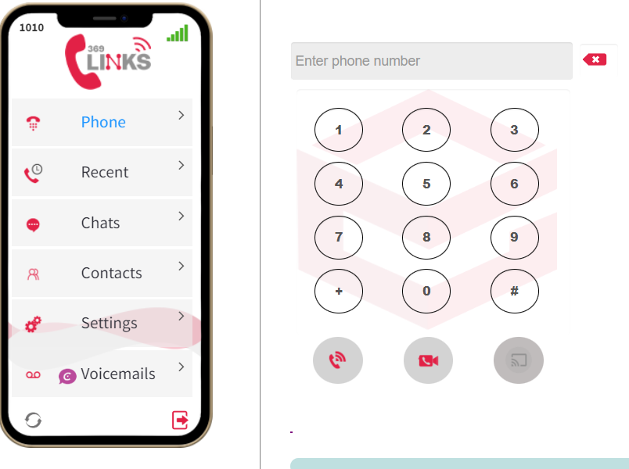

In the phone tab option

* You can make normal calls
* A video call option also is there
* During the calls you can mute the call
* Transfer the call options also is there

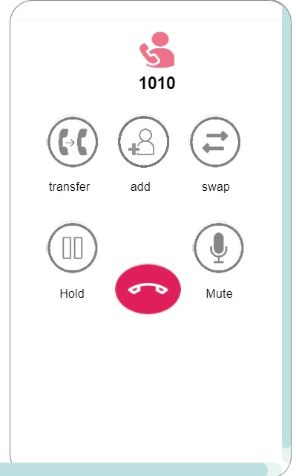 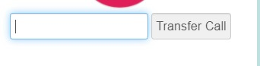

* You can add the peoples
* And hold option also is there
* So if you want to call a local number you have to add ‘0’ in the beginning.

**2.Recent:**

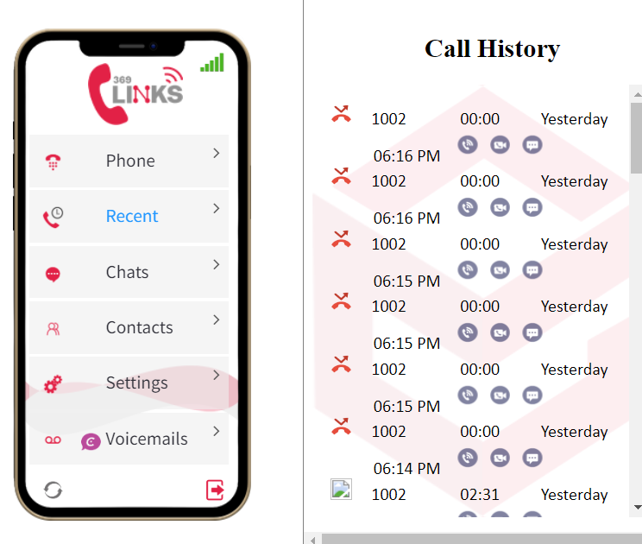

In the recent option

* you can see what all recent calls you made recently.
* If any missed calls are there you can check.
* and in that you can also dial those same numbers that you dialed previously.
* **Chat option in the ‘recent’**

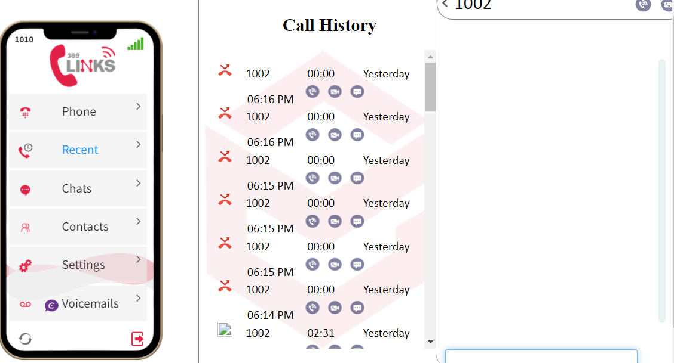

* In the recent option you also have an option called chat.
* If you don't want to call them back, you can just chat with the help of this.
* **Video call option in the ‘recent’**

**(include screenshot)**

* In the recent option you also have an option called video call
* In this you can make video calls
* you can mute the calls also
* in this hold option also is there

**3.Chats:**

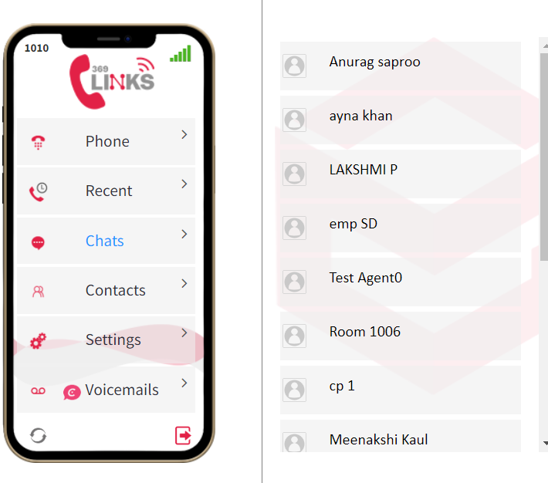

* Click or tab the “chats”
* Press “compose chat”
* This will bring up your company's extension list. Search or scroll to find the extension that you want to chat with and select it. Click “ok” to launch the chat window. You can also select multiple contacts and have a group chat.
* Click on the entry field at the bottom of the chat window and start writing your message. Press “enter” to send your messages.
* **Call option in the ‘chat’**



* in the chat option you can also make calls
* mute options also is there
* and you also have swap option
* and hold option also is there
* and you add the peoples aso
* you can transfer the calls also



**4.Contacts:**

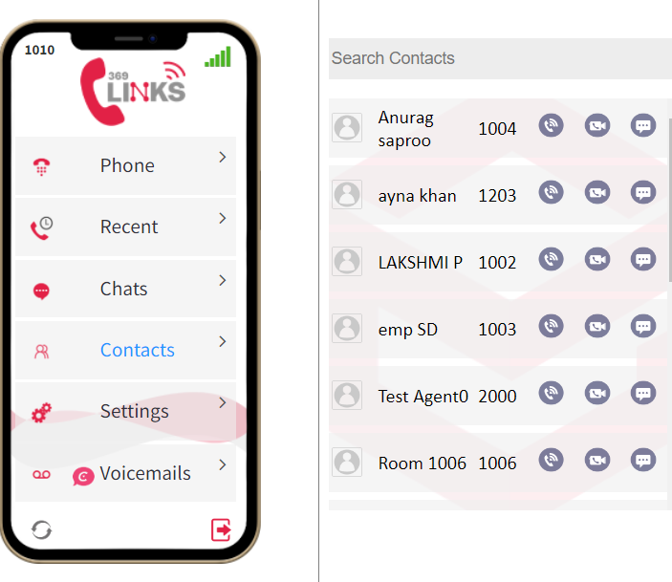

* Contacts overview
* Manage company contacts
* Manage Personal Contacts
* Configure company contacts permission for users
* Identify callers from contacts
* Query and use contacts on an IP phone
* Contact FAQ
* **Calls option in the ‘contacts’**



* in the contacts option you can also make calls
* in that you have hold option
* you have mute option
* you can swap the calls
* you can add the peoples
* you can transfer the calls also



* **Video call option in the ‘contacts’**

**(include screenshot)**

* in the contacts option you can also make video calls
* in that you have hold option
* you have mute option
* you can swap the calls
* you can add the peoples

**5. Settings:**

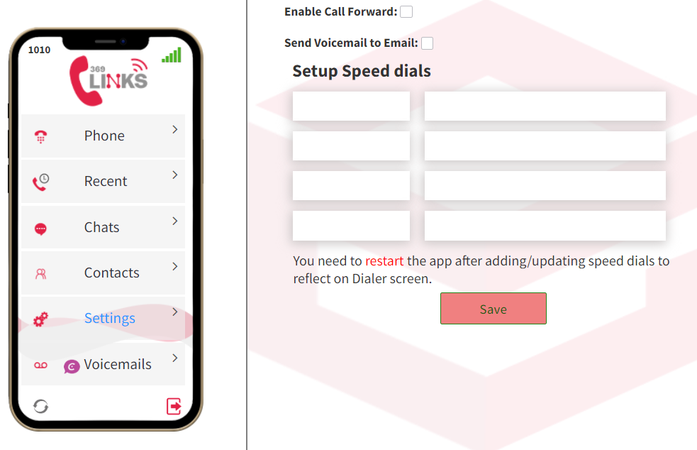

In the settings option

* you can enable call forward
* after enabling call forward you will get some options,

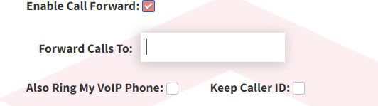

* you can send voicemail to emails
* in this you can set up your speed dial
* After that you can save.

**6. Voicemails:**

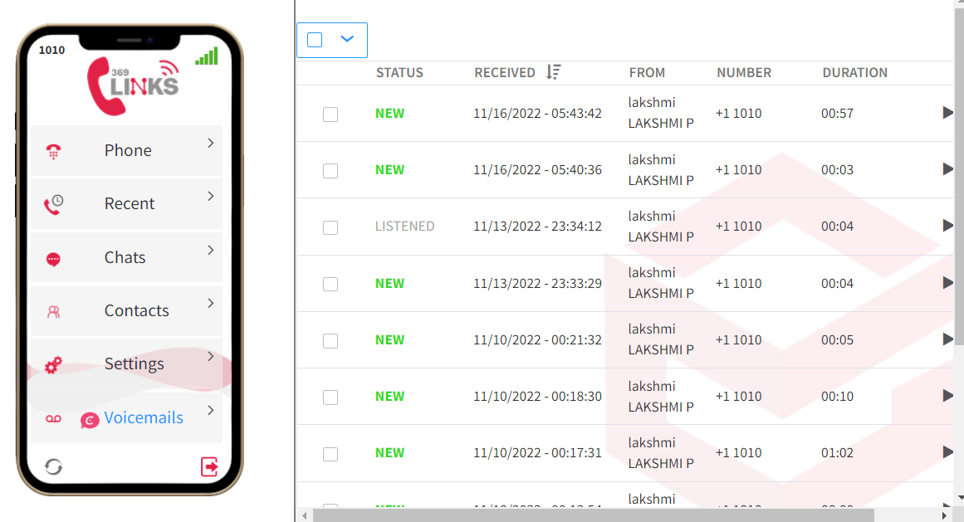

* In the voicemails you can dial the Transfer to voicemail command on one of the desk phones, to access the voicemail greeting of your phone, so you could enter your pin and check the voicemails from the remote extension.
* A feature which allows you to prompt a caller to leave a message in the event that no one answers an incoming call.
* In this you can check the Status of your voicemails also.
* And you have the option of downloading voicemail.

**Using the Mobile Phone App**

1. **Mobile app**

To Download mobile app, go to below link  
  
Android App: <https://play.google.com/store/apps/details?id=com.grandstream.wave>   
  
IOS App: <https://apps.apple.com/in/app/grandstream-wave-lite/id1029274043>

1. Give Permission (Allow) To all below settings:  
   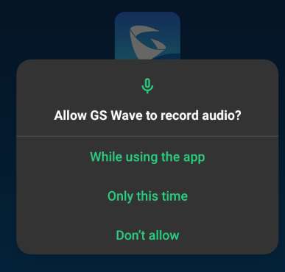 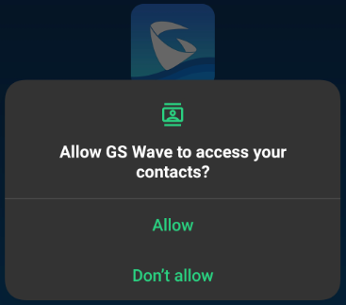 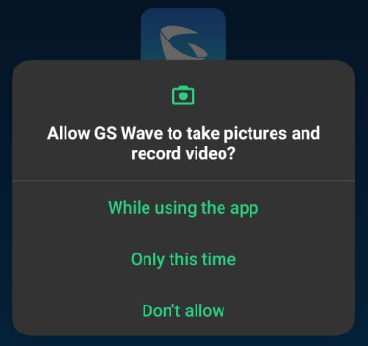 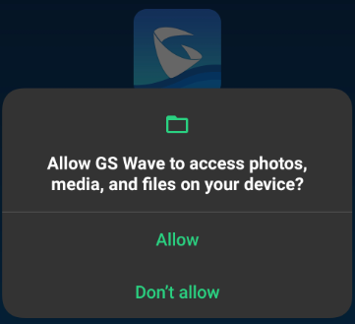 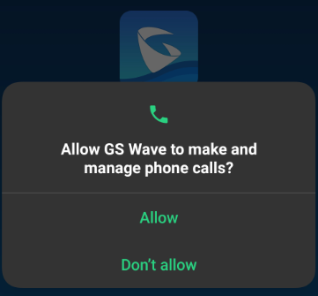
2. Once you open the app you will see this window,  
   from here go to **settings**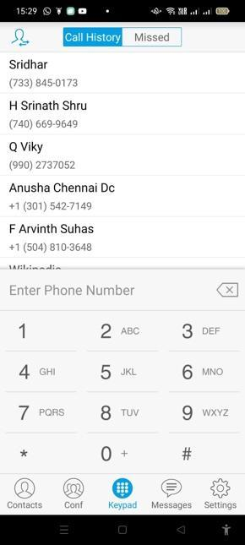
3. Go to **Account settings**: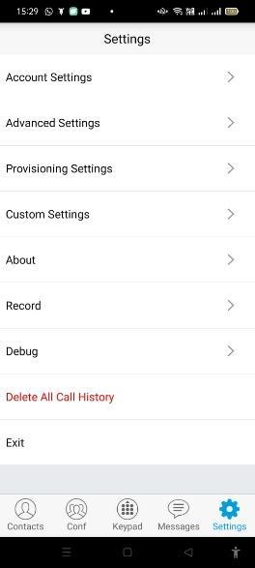

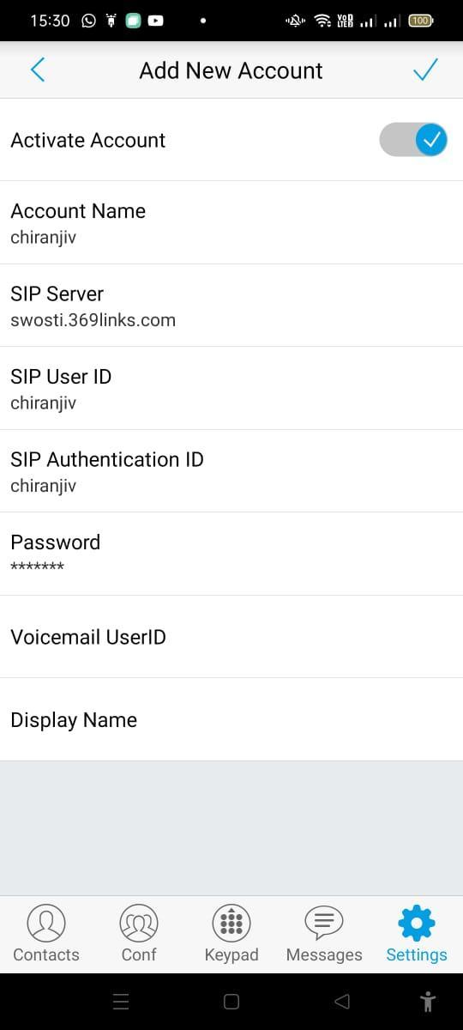

1. Go to Account settings:  
   Click on **“+”** button on top right corner

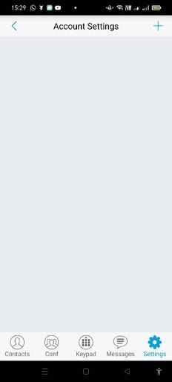

1. Go to **SIP Account**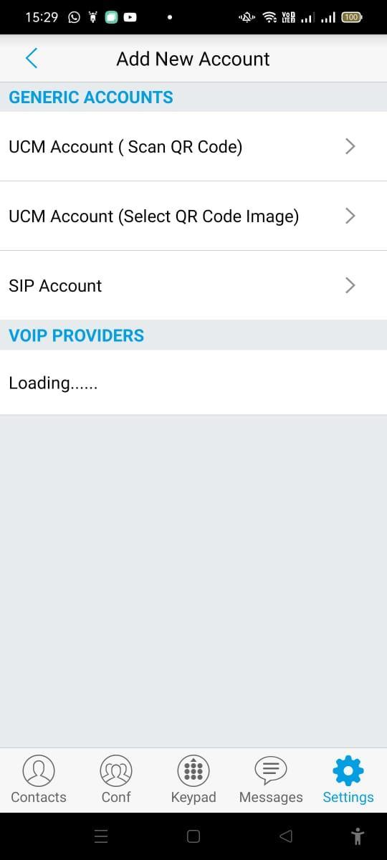
2. Enter the following credentials to activate the account.  
   **Example:**  
   **Account Name** : Display Name  
   **SIP Server:** vervenest.369links.com  
   **SIP User ID:**600  
   **SIP Authentication ID:** 600 ( Same as SIP User ID)  
   **Password:** test123

Click on **right** symbol and save it

1. Now Again Go to   
   **settings** 🡪 **Account settings** 🡪 Click Display Account 🡪 scroll Down to **Network settings** 🡪 Tap On **Outbond Proxy** and give the below details.  
     
   **sbc01.in.369links.com**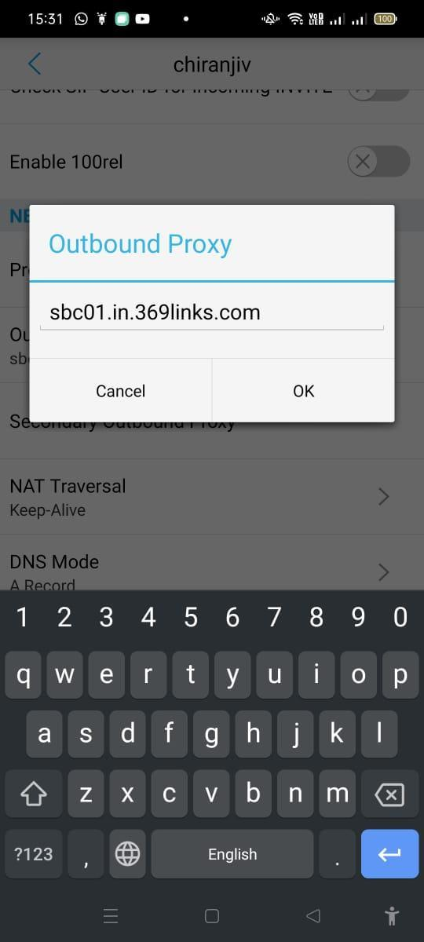

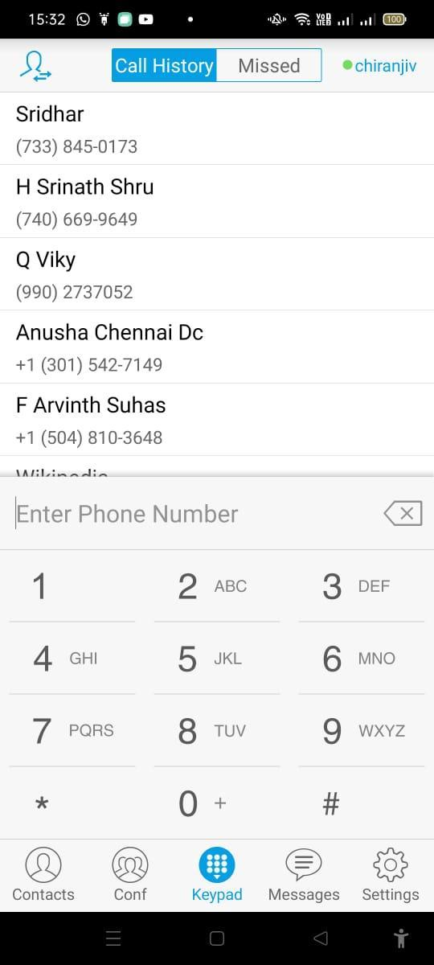

You can see the green dot before the display name which means your account is active now and you can start using it.

**Using GS wave lite app settings for better performance**

1. Increase seconds in Account Settings - select the account- SIP settings- Session expiration settings - session expiration & MIn- SE
2. Account Settings - select the account - SIP settings- Register Expiration(m) - increase the minutes
3. Account Settings - select the account - SIP settings- Transmission protocol to TLS
4. Prevent App sleeping in the background

The below steps should work for most Android phones with Oreo (Android 8.0) or above. Some smartphone manufacturers, however, completely replace Android's battery optimization for their own implementations.

1. Locate the app you want to work more reliably on your homescreen or launcher.
2. Hold and tap it to invoke the long-press menu, and then select the **App info** shortcut (it should be an **(i) symbol** or something along those lines).
3. Locate the **Battery** entry in the menu that just opened and tap it.
4. On the next screen, select **Unrestricted,** which will allow the app in question to run with far fewer limits while in the background.

 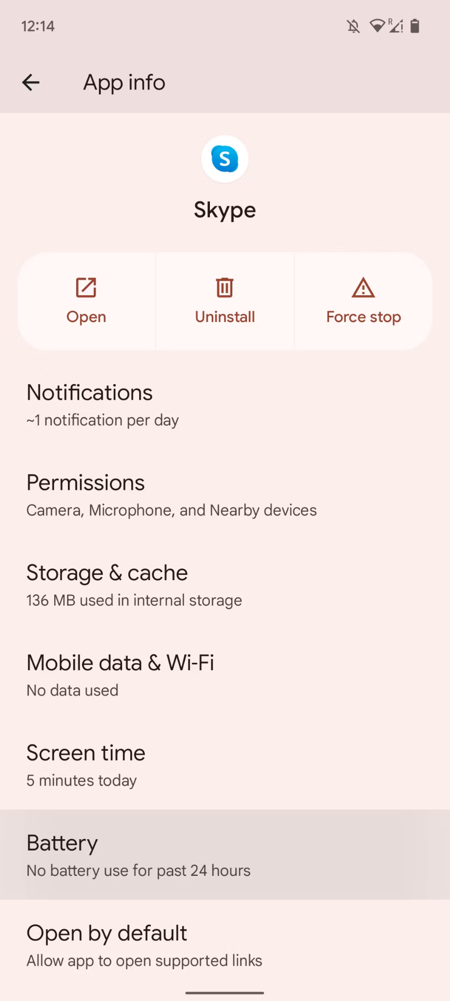 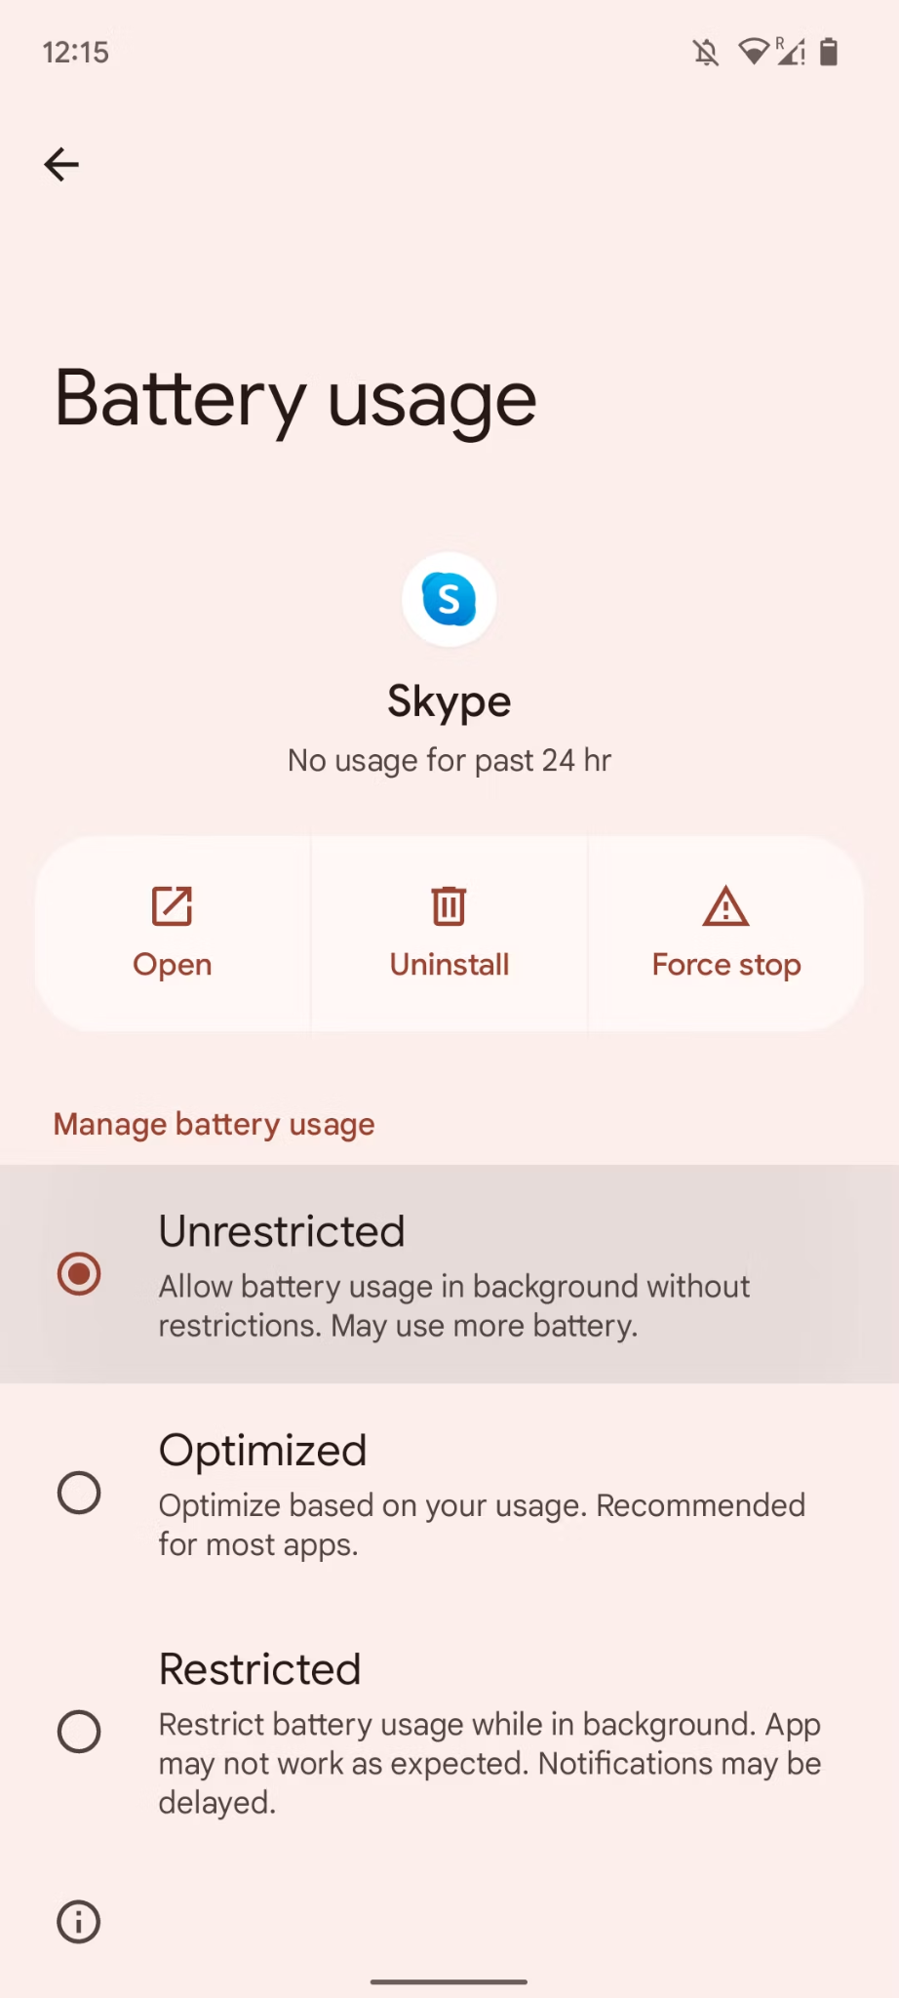

**Descriptions:**

**What is Cloud PBX?**

A cloud Private Branch Exchange (PBX) is a business phone system where the service provider stores your business communication data in the cloud. It’s also known as a virtual PBX or [hosted PBX](https://www.nextiva.com/blog/what-is-hosted-pbx.html) because the network is hosted away from your office, unlike a traditional PBX where the data center is in your place of work.

Cloud PBX users access their system with an internet connection and an internet-connected device, like a mobile phone or laptop, to make VoIP calls. That’s the only equipment you’ll need, making it a popular choice for large and small businesses.

With cloud PBX, you can run your entire business phone system over an internet connection. It allows your team to make and receive calls from anywhere, not just the office.

**Features of Cloud PBX is,**

1. Auto attendant
2. Call reporting and analytics
3. Interactive Voice Response (IVR)
4. Free local and toll free numbers
5. Audio and Video conferencing
6. Call encryption
7. Voicemail to email
8. Advanced call routing
9. Call recording
10. Call forwarding
11. Click to call
12. Mobile and desktop apps
13. **Auto Attendant:**

An [auto attendant](https://www.nextiva.com/features/voip/auto-attendant.html) does exactly that. It acts as a virtual receptionist that greets incoming callers and routes them to the necessary departments. If you’ve ever heard, “Press 1 for Sales, Press 2 for Support,” then you’ve used an auto attendant.

Not only does an auto-attendant reduce costs by removing the need for a human receptionist, but it’s superb for customer satisfaction. Plus, auto attendants add a professional touch for incoming callers. A simple greeting that introduces your company and thanks the person for calling can go a long way for building credibility.

1. **Call reporting and analytics:**

If you run a large scale call center or manage a busy sales team, phone call reporting capabilities are key. They’ll tell you [real-time call analytics](https://www.nextiva.com/features/voip/call-analytics.html) about your business phone usage, including:

* Time spent on phone calls
* Number of answered, missed, and toll-free calls
* The most popular time of day for phone calls
* Which team member answers the most calls

Each of these gives you better insights into how your business uses the phone system. For example, if you find that sales rep #1 spends half the time on sales calls than other reps but still closes the same amount of deals, you can ask them to share their script.Having access to call data makes it easier for you to spot quick-wins or pain points. Unlike a traditional PBX, you’ll know exactly where your team is spending their time.

**3.Interactive Voice Response (IVR):** An [Interactive Voice Response (IVR)](https://www.nextiva.com/blog/interactive-voice-response-ivr.html) functions similarly to an auto-attendant, except instead of pressing numbers on your dial pad, you simply say the department you’d like to be routed to, advanced IVR built with conversational AI. Either option is suitable for businesses with lots of inbound call traffic.IVR is a great way to stay on-brand with your business communications policy. It also lets you provide self-service options for customers.

**4.Free local and toll free numbers:**

Customers may incur calling fees if they’re calling a business’ toll number. But with a toll-free number, customers won’t be charged extra fees for contacting you from a landline. Your business’ caller ID will show an area code that doesn’t charge extra fees.These phone numbers can have a positive effect on your sales team, too. According to toll-free numbers, people calling toll-free numbers order more products and higher ticket items 95% of the time.Area codes aren’t just important for customers to see if they’ll incur extra fees. Unfamiliar area codes on the caller ID could be the reason they’re not picking up the phone. According to Software Advice, people are nearly four times more likely to answer calls from local numbers.Check whether your provider offers free local virtual numbers to cash in on the trust people have with local, recognizable area codes.

**5.Audio and Video conferencing:** A cloud PBX system does more than make and receive phone calls. Some providers allow you to host [video and audio conference calls](https://www.nextiva.com/features/voip/conference-calling.html) with your team.This works by creating a virtual meeting room, called a conference bridge, with a corresponding passcode for your team to join. They can use any internet-connected device to join the conference, including their softphone, VoIP headset, or mobile phone. Each person can hear the conversation, jump in where necessary, and even take turns sharing their screens for better collaboration.The best part? Call quality doesn’t suffer when you’re in a conference. Since VoIP calls are made through the internet, you’ll only need a strong bandwidth to have conference calls.

**6.Call encryption:** Call encryption (TLS and SRTP) A data breach in the U.S. can cost businesses an average of $3.68 million. It’s no surprise why security is a major factor when you’re choosing a cloud PBX phone solution.However, VoIP calls are highly secure if your provider offers call encryption. Inbound calls have two layers added to the digital connection, including:

* Transport Layer Security (TLS)
* Secure Real-time Transport Protocol (SRTP)

**7.Voicemail to email:** Most business phone systems have a cluttered and unorganized voicemail system. That doesn’t have to be the case with a cloud PBX phone system.[Voicemail to email](https://www.nextiva.com/features/voip/voicemail-to-email.html) is a feature that takes your voicemail recordings and delivers them to your email inbox. You’ll get a notification each time a voicemail is left on your VoIP number, and an email containing the MP3 file. You can then listen to it on your computer and follow-up at your convenience.Some providers also offer voicemail transcription features. It’ll deliver the same voicemail, only you’ll see a transcription of it in plain text, as well as audio format. This makes it easier for you to return calls, make notes, and share call information with your team.

### **8. Advanced call routing and queuing:** A major benefit of using a hosted PBX is [call routing](https://www.nextiva.com/blog/what-is-call-routing.html) and call queuing. Agents might not be able to answer all phone calls immediately, but instead of the calls failing or being stuck on hold, inbound callers will join a call queue. An automated message will tell them what position in the queue they’re in, how long they should expect to wait, and thank them for their patience.If a call goes through to the incorrect team, advanced call routing diverts the call to the most relevant agent. Callers won’t need to join the queue again. This makes call routing and queuing perfect for high volume [call centers](https://www.nextiva.com/products/voip-call-center-solutions.html).

### **9. Call recording:** [Business call recordings](https://www.nextiva.com/features/voip/call-recording.html) are great resources for team training. You can replay recordings to review which sales scripts work best, and which customer support queries need answering most often. You can also use call recordings to prepare new employees for handling awkward situations using real-life examples.Plus, access to call recordings helps with staff accountability. Should you need to clarify who said what, you’ll have a repository of recordings to go back and listen to for up to six months. This can help minimize legal risks, depending on who the conversation involves.

### **10. Call forwarding:** [Call forwarding](https://www.nextiva.com/features/voip/call-forwarding.html) diverts calls from your in-office desk phone to your mobile phone without any interruptions. The person on the end of the line wouldn’t notice any difference, which makes this a great feature for on the go employees.You can even change your cloud PBX settings to automate call forwarding. It’s useful for situations where you know you won’t be able to take calls on your regular device, like if you work from home on a Tuesday or are out of office for the holidays.

### **11. Click to call:** With click to call capabilities, you can press a phone number on a device and immediately call a local business – hence why you might see this feature labeled as one-click calling.Click to call allows you to take advantage of web traffic and make it easier for customers to call you. They don’t need to copy and paste the number into their cell phone. They’ll just click the phone button and a connection will be established.

### 

### **12. Mobile and desktop app:** Having a mobile and desktop app with a coherent user interface can be a gamechanger for team productivity. It also allows employees to take conversations anywhere and still be in the loop. This is especially important with the rise of remote work.It’s important to check whether your provider has a compatible app for the devices you’re already using. This can include mobile apps for devices running on iOS, Android, and Google.The best part? All of this contributes to bigger cost savings. You don’t need to run out and replace all of your equipment when using a cloud PBX, nor buy a new desk phone when a team member joins. With a compatible mobile app, they can use their existing devices to get up and running instantly.

These are the basic steps to be followed for customer registration, creating users, groups and setting devices for users. For further queries and/or assistance please feel free to contact our customer care centre at

[support@eastsideworld.com](mailto:support@eastsideworld.com)